Tribhuvan University
Institute of Science and Technology



Central Department of Computer Science and Information Technology
Kirtipur, Kathmandu

Computational Geometry
Assignment
Lab 1: Implementation of Geometric Objects

Submitted by: Submitted To:
Name: Rishav Acharya Asst. Prof. Jagdish Bhatta
Roll No.: 01/077
Date: 20-July-2022
Lab 1: Write a program to implement following geometric objects
- Point
- Line Segment
- Ray
- Line

Answer

Code can be found on: https://colab.research.google.com/drive/1kjThFwOgLdRUP8jZpVhMdwHlo2KpQpHn

1: Point
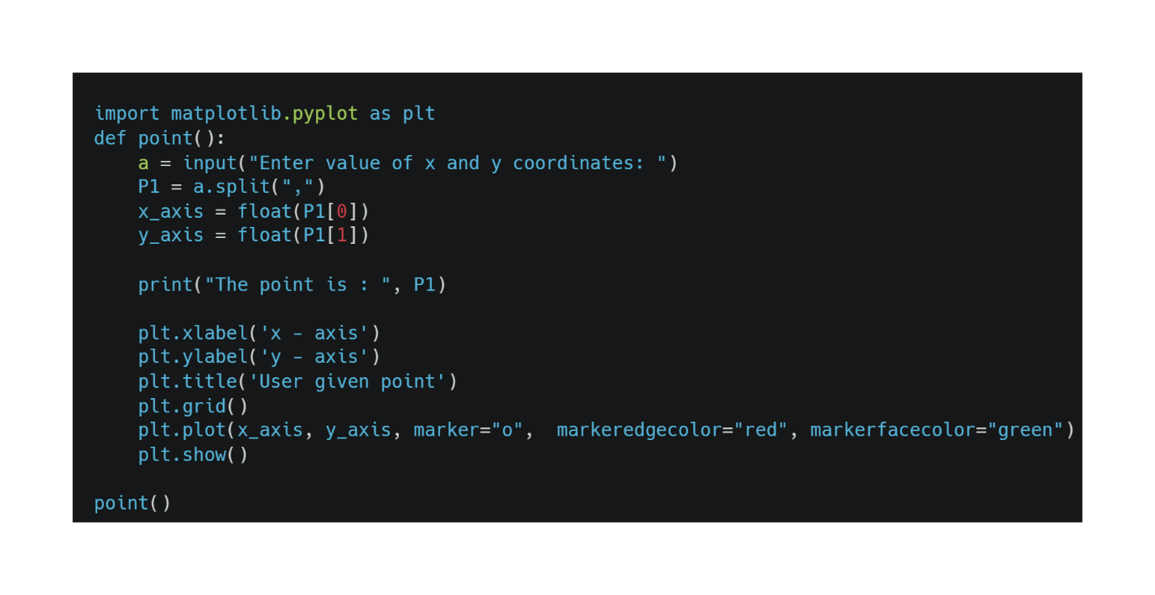
Output:

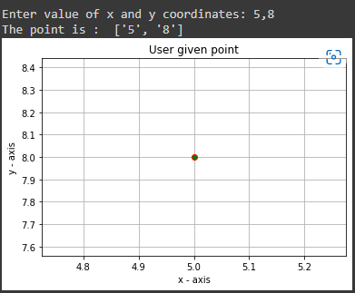

2: Line Segment

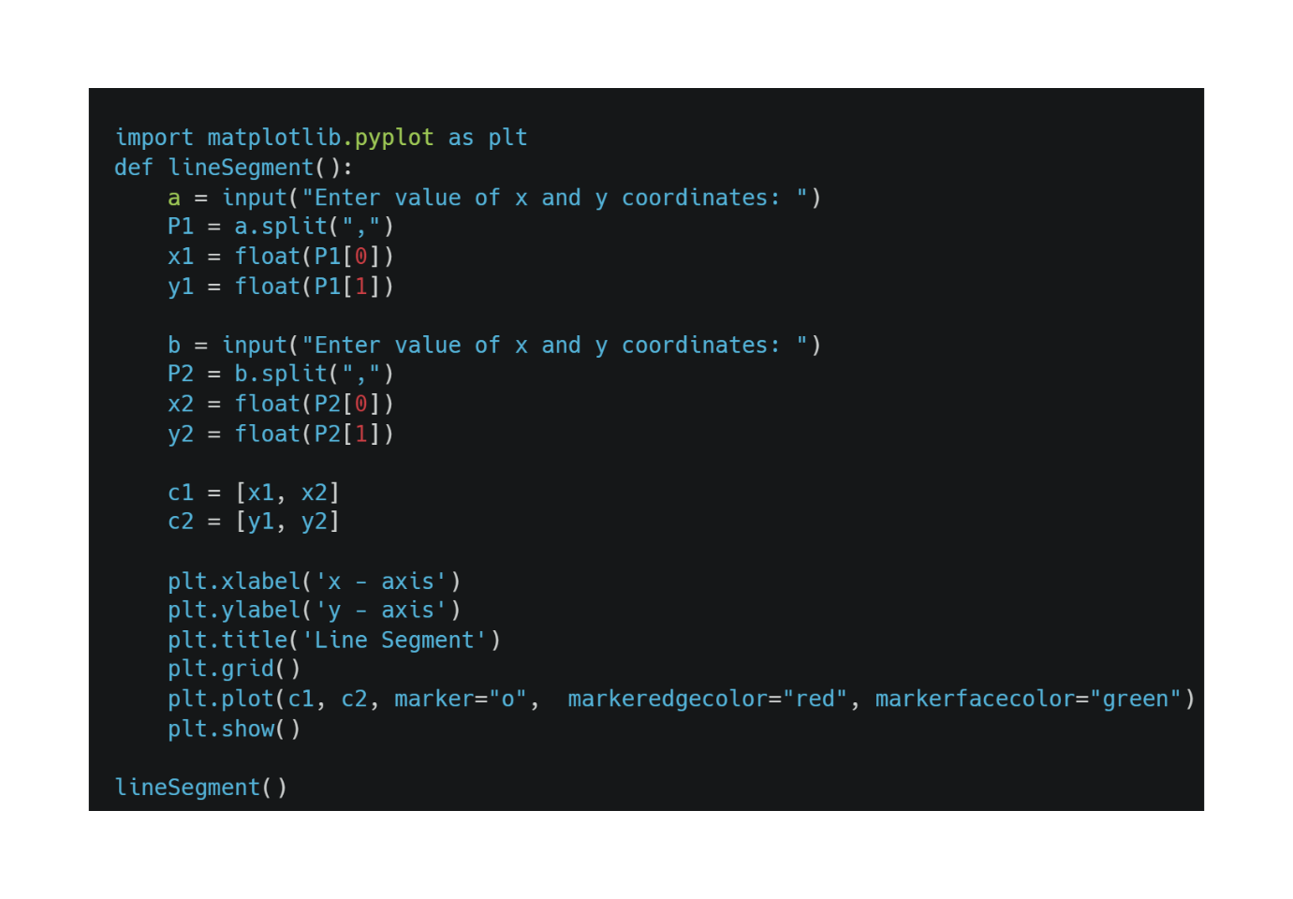

Output:

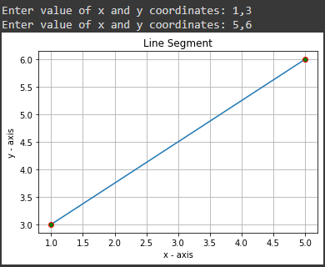

3: Ray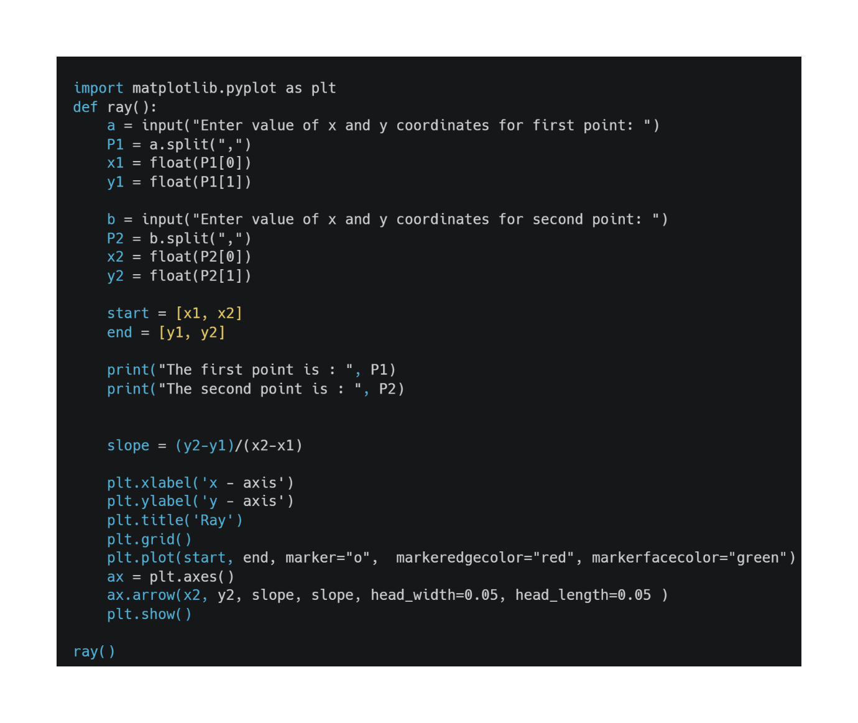Output:
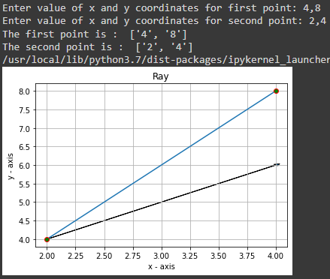
4: Line
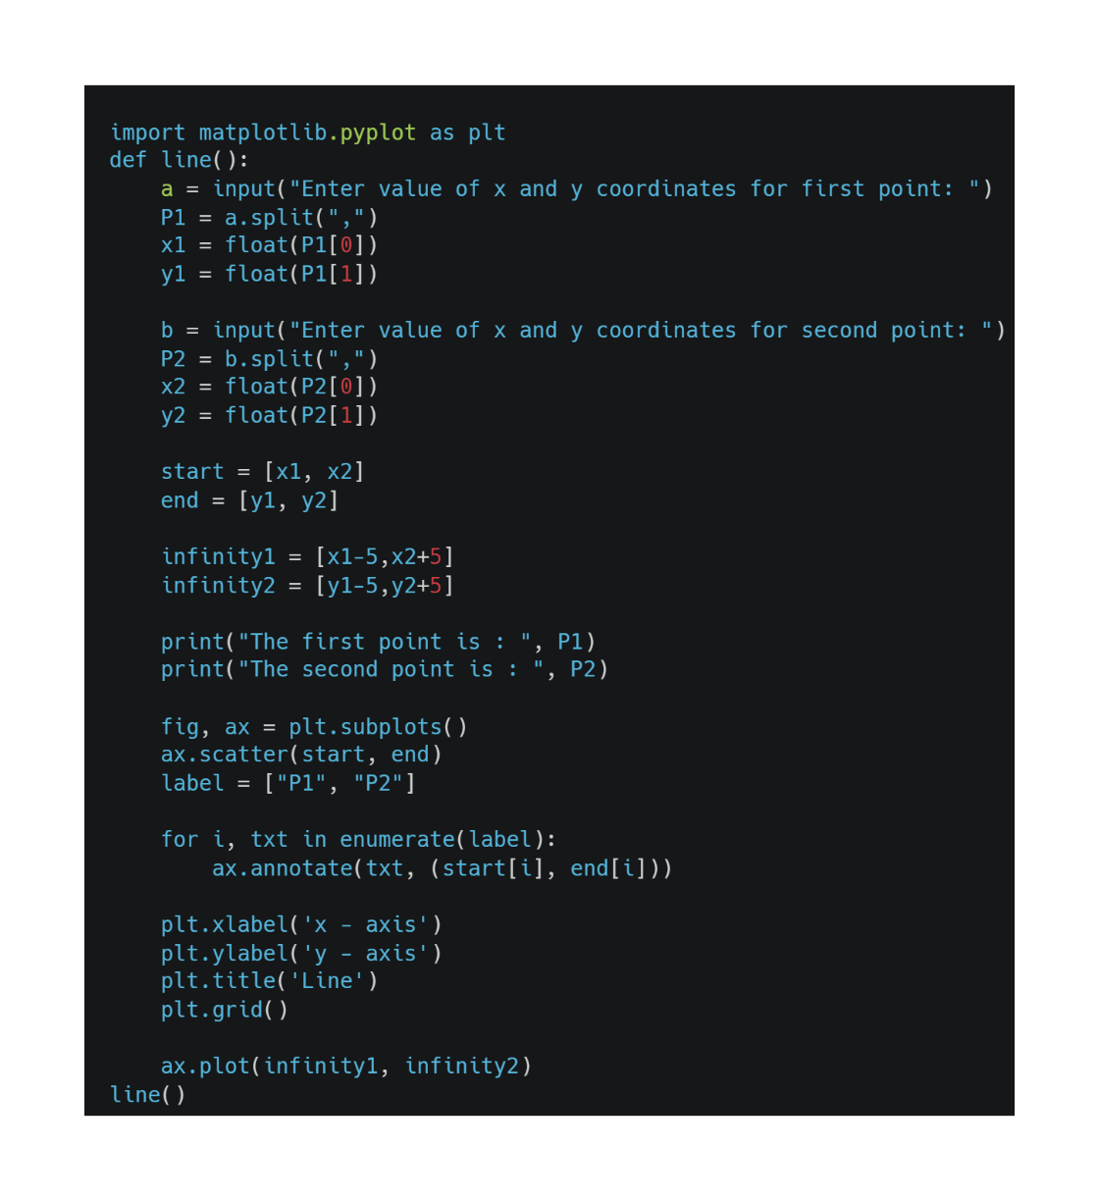
Output:
